Thermal fogging
currency sanitising machine
ABSTRACT
This report will give the reader an overview about the steps which are involved in the making of a Thermal fogging currency sanitising machine. These machines are an environmentally-friendly solution for sanitising the currency. With the help of this machine people will be able to exchange sanitised or clean money at grocery store and other shops. It is an automatic machine that runs through sensors. It is based on thermal fogging. Thermal fogging is the generation of ultra-fine droplets in a range of 1-50 µm using thermo- pneumatic energy. Liquid substances are vaporised at the end of fogging barrel (resonator) and form ultra-fine aerosols by condensing on contact with cool ambient air, on being ejected, to create dense visible fog-clouds. A fogging machine disperses an antibacterial spray to accomplish this. This can be used at the grocery store and other relevant shops.

Table of contents
Chapter 1………………………………………………………
INTRODUCTION
- Thermal fogging currency sanitising machine
- Overview
- Purpose of the project
- Application of the project
Chapter 2……………………………………………..
TOOLS AND TECHNIQUES
- HARDWARE
- Nichrome heat element
- Copper tube
- Aluminium pipe
- Thermal switch
- Submersible pump
- PVC pipe and frame/body
- Sensors
- Microcontroller
- Relay and wires
- TOOLS
- Welding station
- Drill machine
- Screw driver etc.
CHAPTER 3…………………………………………..
COST
ALL HARDWARES
CHAPTER 4…………………………………………..
CONCLUSION
CHAPTER 1
INTRODUCTION
THERMAL FOGGING CURRENCY SANITISING MACHINE:
A Thermal fogging currency sanitising machine is designed for decontamination or sanitised of money from one individual to others at grocery store and other shops. The decontamination is started with the help of sensors also we can operate manually with the help of switch and preventing the money from bacteria, germs and virus. When the money will be given from one people to another through the machine then, electrically operated pump creates a disinfectant fog of sanitizer for disinfecting. The fog spray from currency sanitising machine will turned ON when exchanging of money from one person to other.
OVERVIEW:
Here is a circuit diagram of thermal fogging currency sanitising machine and coil.

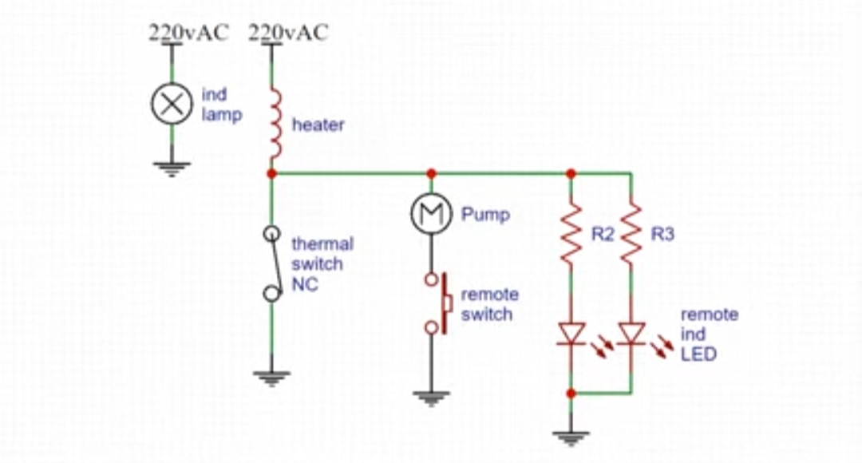

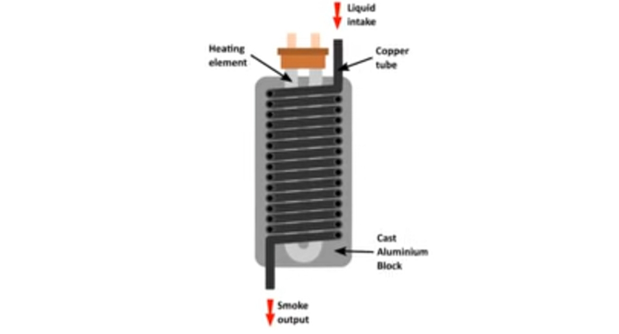

PURPOSE OF THE PROJECT:
The purpose of project is to make a that type of machine which can protect or prevent from COVID-19 Virus or Pandemic. With the help of this machine we can prevent COVID-19 virus from spreading less.

APPLICATION OF THE PROJECT:
This can be used at the grocery store and other relevant shops.

CHAPTER 2
TOOLS AND TECHNIQUES
HARDWARE:
1.Nichrome heat element


2.Copper tube

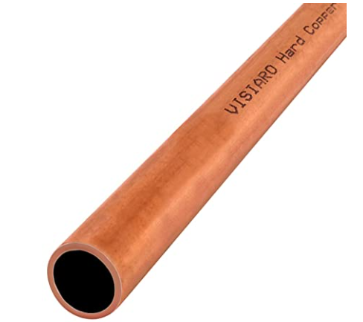

3.Aluminium pipe


4.Thermal switch

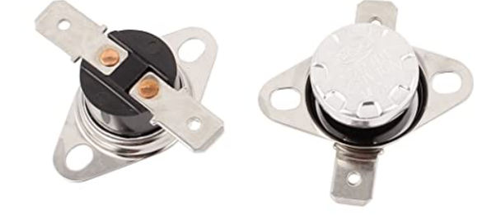
5.Submersible pump
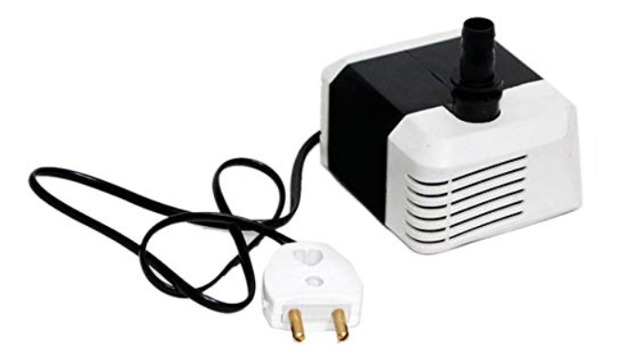

6.PVC pipe and frame/body

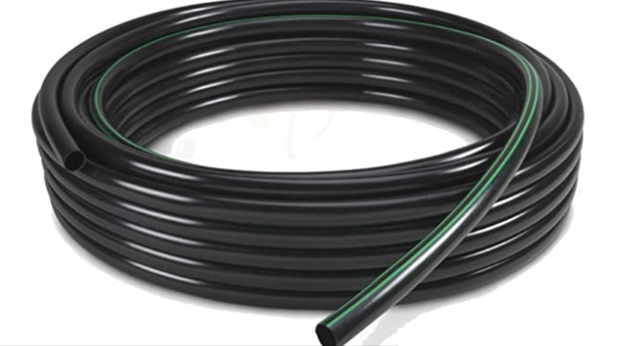

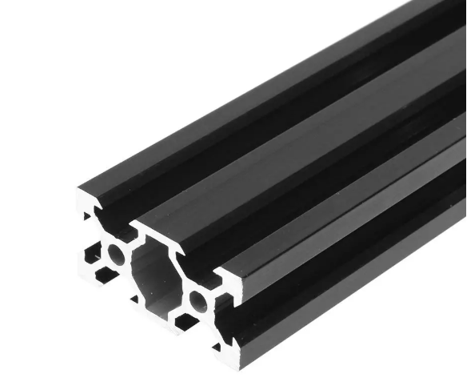
7.Sensors
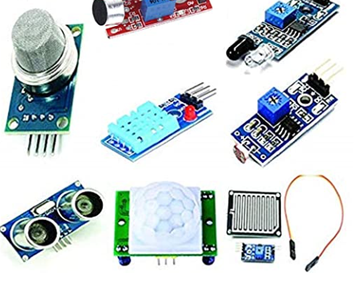

8.Microcontroller
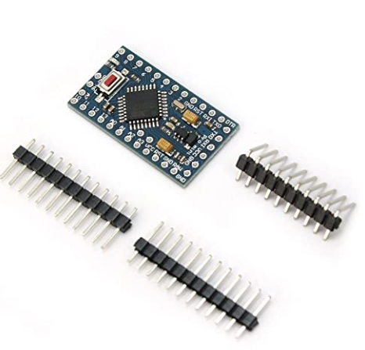
9.Relay and wires

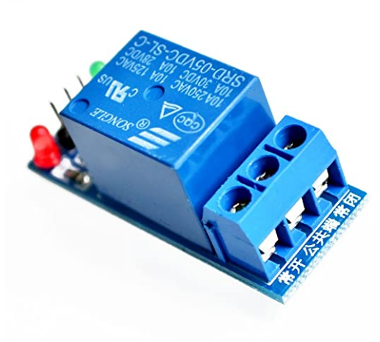
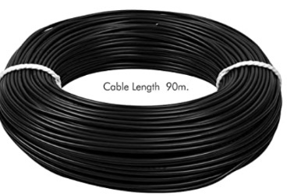

CHAPTER 3
ESTIMATE COST:
1.Nichrome heat element--------------------80Rs/-
2.Copper tube---------------------------------250Rs/-
3.Aluminium pipe----------------------------100Rs/-
4.Thermal switch-----------------------------300Rs/-
5.Submersible pump------------------------150Rs/-
6.PVC pipe and Frame/body---------------200Rs/-
7.Sensors--------------------------------------150Rs/-
8.Microcontroller-----------------------------320Rs/-
9.Relay and wires----------------------------150Rs/-
TOTAL=====1700Rs/-

CHAPTER 4
CONCLUSION:
According to my research, the best and easiest way to stay healthy is to wash your hands and sanitised your body with alcohol-based reagent. The data showed that washing hands with soap and water effectively reduced the number of germs on hands by 12-50%. Using hand sanitizer to clean hands reduced the number of germs present by 35-70%.

